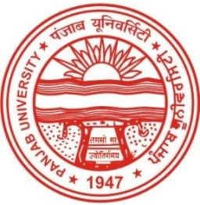**CHANDIGARH COLLEGE OF ENGINEERING AND TECHNOLOGY**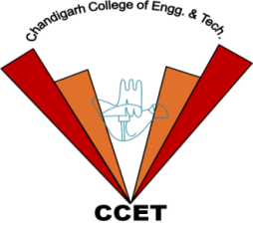

**(DEGREE WING)**

**Government Institute under Chandigarh (UT) Administration | Affiliated to Panjab University , Chandigarh**

**Sector-26, Chandigarh. PIN-160019 | Tel. No. 0172-2750947, 2750943**

**CERTIFICATE**

**This is to certify that Mr./Ms. &NAME& S/D of Mr./Sh./S. &FATHER&**

**Roll. No &ROLL& B.E. student of Department of &DEPT& for securing Position - &POSITION& in &EVENT& event as a part of ANNUAL ATHLETIC MEET - 2018 held on 26-27 February, 2018 at Chandigarh College of Engineering and Technology (Degree Wing), Sector-26, Chandigarh .**

**Er. Sarabjeet Singh Dr. Radhey Sham Prof.(Dr.) Rajesh Kumar Prof.(Dr.) M. S. Gujral**

**(Sports In-Charge) (President Student Council) (President Student Welfare) (Principal)**